Engineering Services
Chapter
11
Engineers and Builders...

Reinforced Concrete Section Capacity Engineer
Encapsulates the solution to the reinforce concrete section capacity problem in a high level engineer class.

Requirements

Logical Design

Static Models
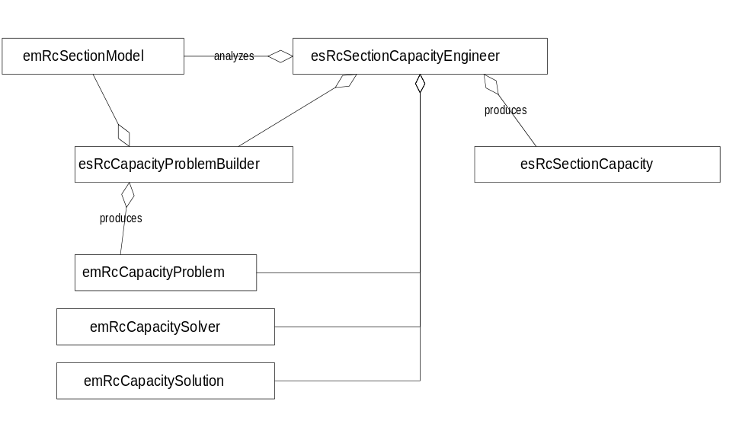

Dynamic Models

Physical Design

Specifications

esRcSectionCapacityEngineer
Encapsulates the procedure needed to determine the capacity of a reinforce concrete section.

Public Interface - Member Functions
emRcSectionCapacityEngineer
emRcSectionCapacityEngineer();
Constructor
ComputeCapacity
static esRcSectionCapacity ComputeCapacity(const emRcSectionModel* pModel,
Method method,
Float64 P,
Float64 angle);
static esRcSectionCapacity ComputeCapacity(const SomeProductModel* pModel,
Method method,
Float64 P,
Float64 angle);
Computes the capacity of the section given the applied axial load P and the arctangent of the moment interaction ratio, angle, using the specified method. Returns a capacity object. A XCapacityError exception is thrown if the capacity could not be computed.

Public Interface - Enumerations
Method
enum Method { WhitneyMethod = 0,
NaamanMethod };
Methods of solution.

esRcSectionCapacityEngineer::XCapacityError
Exception class thrown when a esRcSectionCapacityEngineer could not determine the capacity of a concrete section.

Public Interface - Member Functions
GetReason
esRcSectionCapacityEngineer::XCapacityError::Reason GetReason() const;
Returns the reason why the capacity could not be calculated.

Public Interface - Enumerations
Reason
enum Reason { Unknown,
TensileCapacityExceeded
CompressiveCapacityExceeded
ReinforcementRuptured
};
Reasons why the capacity engineer could not calculate the capacity of the section.
These reasons are really dependent on the reasons emRcCapacitySolver fails.

esRcSectionCapacity
Encapsulates the capacity of a reinforced concrete section.

Public Interface - Member Functions
emRcSectionCapacity
emRcSectionCapacity(Float64 P,Float64 Mx, Float64 My);
Constructor.
GetAxialLoad
Float64 GetAxialLoad() const;
Returns the applied axial load.
GetMx
Float64 GetMx() const;
Returns the moment capacity about the x axis.
GetMy
Float64 GetMy() const;
Returns the moment capacity about the y axis.

esRcCapacityProblemBuilder
Builds an emRcCapacityProblem from an emRcSectionModel.

Public Interface - Member Functions
Build
static emRcCapacityProblem* Build(const emRcSectionModel& rSectionModel);
Builds an emRcCapacityProblem from an emRcSectionModel. This is a factory method. You are responsible for destroying the emRcCapacityProblem object when you are finished with it.

Implementation Notes

Accounting for holes in concrete at reinforcement locations.
The builder must be very careful to account for the holes in a primary concrete section when reinforcement is placed in the section. To account for this, concrete elements with negative areas, equal to the area of the reinforcement, must be added to the model at the same location as the reinforcement causing the hole.

